You are invited to . . .
Community Movie Night & Social
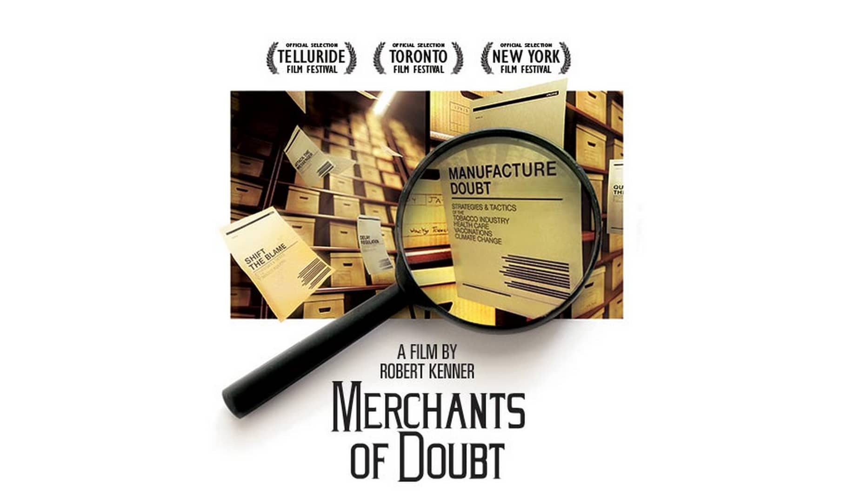 Friday Sept 15 - 7pm
Mt. Horeb Community Center 107 N Grove St
*Social Time and Snacks precede the movie at 6pm
*RSVP's are helpful for planning! RSVP @ mounthorebccl.info

“Eye-Opener!”- Peter Howell, TORONTO STAR
“Entertaining” – Justin Chang, VARIETY
“Potent!” “Enlightening” – Stephen Farber, HOLLYWOOD REPORTER
“Provocative” – Joe Morgenstern, WALL STREET JOURNAL

Merchants of Doubt was nominated for the Humanitas Prize in 2014 and the PGA awards in 2015 and won the Hollywood Music in Media 2014 Award for Best Original Score Documentary. This community event is sponsored by The Mount Horeb Area Citizens’ Climate Lobby Chapter. (Merchants of Doubt is rated PG-13, 96 minutes)

